

Semester One Examination, 2017

Question/Answer booklet

MATHEMATICS

SOLUTIONS
METHODS
UNIT 3

Section Two:

Calculator-assumed

Student Number: In figures

In words

Your name

Time allowed for this section
Reading time before commencing work: ten minutes
Working time: one hundred minutes

Materials required/recommended for this section
To be provided by the supervisor
This Question/Answer booklet
Formula sheet (retained from Section One)

To be provided by the candidate
Standard items: pens (blue/black preferred), pencils (including coloured), sharpener, correction fluid/tape, eraser, ruler, highlighters

Special items: drawing instruments, templates, notes on two unfolded sheets of A4 paper, and up to three calculators approved for use in this examination

Important note to candidates
No other items may be taken into the examination room. It is your responsibility to ensure that you do not have any unauthorised material. If you have any unauthorised material with you, hand it to the supervisor before reading any further.

Structure of this paper

Section | Number of questions available | Number of questions to be answered | Working  time (minutes) | Marks available | Percentage of examination
Section One:  Calculator-free | 8 | 8 | 50 | 52 | 35
Section Two:  Calculator-assumed | 11 | 11 | 100 | 98 | 65
 |  |  |  | Total | 100

Instructions to candidates

1. The rules for the conduct of examinations are detailed in the school handbook. Sitting this examination implies that you agree to abide by these rules.

2. Write your answers in this Question/Answer booklet.

3. You must be careful to confine your response to the specific question asked and to follow any instructions that are specified to a particular question.

4. Additional working space pages at the end of this Question/Answer booklet are for planning or continuing an answer. If you use these pages, indicate at the original answer, the page number it is planned/continued on and write the question number being planned/continued on the additional working space page.

5. Show all your working clearly. Your working should be in sufficient detail to allow your answers to be checked readily and for marks to be awarded for reasoning. Incorrect answers given without supporting reasoning cannot be allocated any marks. For any question or part question worth more than two marks, valid working or justification is required to receive full marks. If you repeat any question, ensure that you cancel the answer you do not wish to have marked.

6. It is recommended that you do not use pencil, except in diagrams.

7. The Formula sheet is not to be handed in with your Question/Answer booklet.

Section Two: Calculator-assumed 65% (98 Marks)
This section has eleven (11) questions. Answer all questions. Write your answers in the spaces provided.

Working time: 100 minutes.

Question 9 (7 marks)
The voltage between the plates of a discharging capacitor can be modelled by the function $V\left(t\right)=14e^{kt}$, where $V$ is the voltage in volts, $t$ is the time in seconds and $k$ is a constant.

It was observed that after three minutes the voltage between the plates had decreased to 0.6 volts.

(a) State the initial voltage between the plates. (1 mark)
Solution
$$V_{0}=14 \text{volts}$$

Specific behaviours
states value (units not required)

(b) Determine the value of $k$. (2 marks)
Solution
$$0.6=14e^{180k}$$
$$k=-0.0175$$

Specific behaviours
writes equation
solves, rounding to 3sf

(c) How long did it take for the initial voltage to halve? (2 marks)
Solution
$$0.5=e^{-0.0175t}$$
$$t=39.6 \text{s}$$

Specific behaviours
writes equation
solves, rounding to 3sf

(d) At what rate was the voltage decreasing at the instant it reached 8 volts? (2 marks)
Solution
$$V^{'}\left(t\right)=kV$$
$$=-0.0175×8=-0.14$$
$$\text{Decreasing at 0.14 volts/s}$$

Specific behaviours
uses rate of change
states decrease, dropping negative sign

Question 10 (11 marks)
The gradient function of $f$ is given by $f^{'}(x)=12x^{3}-24x^{2}$.

(a) Show that the graph of $y=f(x)$ has two stationary points. (2 marks)
Solution
$$\text{Require} f^{'}\left(x\right)=0 \\ 12x^{2}\left(x-2\right)=0 \\ x=0, x=2$$
$$\text{Hence two stationary points}$$

Specific behaviours
equates derivative to zero and factorises
shows two solutions and concludes two stationary points

(b) Determine the interval(s) for which the graph of the function is concave upward. (3 marks)
Solution
$$f^{''}\left(x\right)=36x^{2}-48x$$
$$f^{''}\left(x\right)>0⇒x<0,x>\frac{4}{3}$$

Specific behaviours
shows condition for concave upwards
uses second derivative
states intervals

(c) Given that the graph of $y=f(x)$ passes through $(1, 0)$, determine $f(x)$. (2 marks)
Solution
$$f\left(x\right)=\int{f^{'}\left(x\right)}dx=3x^{4}-8x^{3}+c$$
$$f\left(1\right)=0⇒c=5$$
$$f\left(x\right)=3x^{4}-8x^{3}+5$$

Specific behaviours
integrates $f^{'}\left(x\right)$
determines constant

(d) Sketch the graph of $y=f(x)$, indicating all key features. (4 marks)

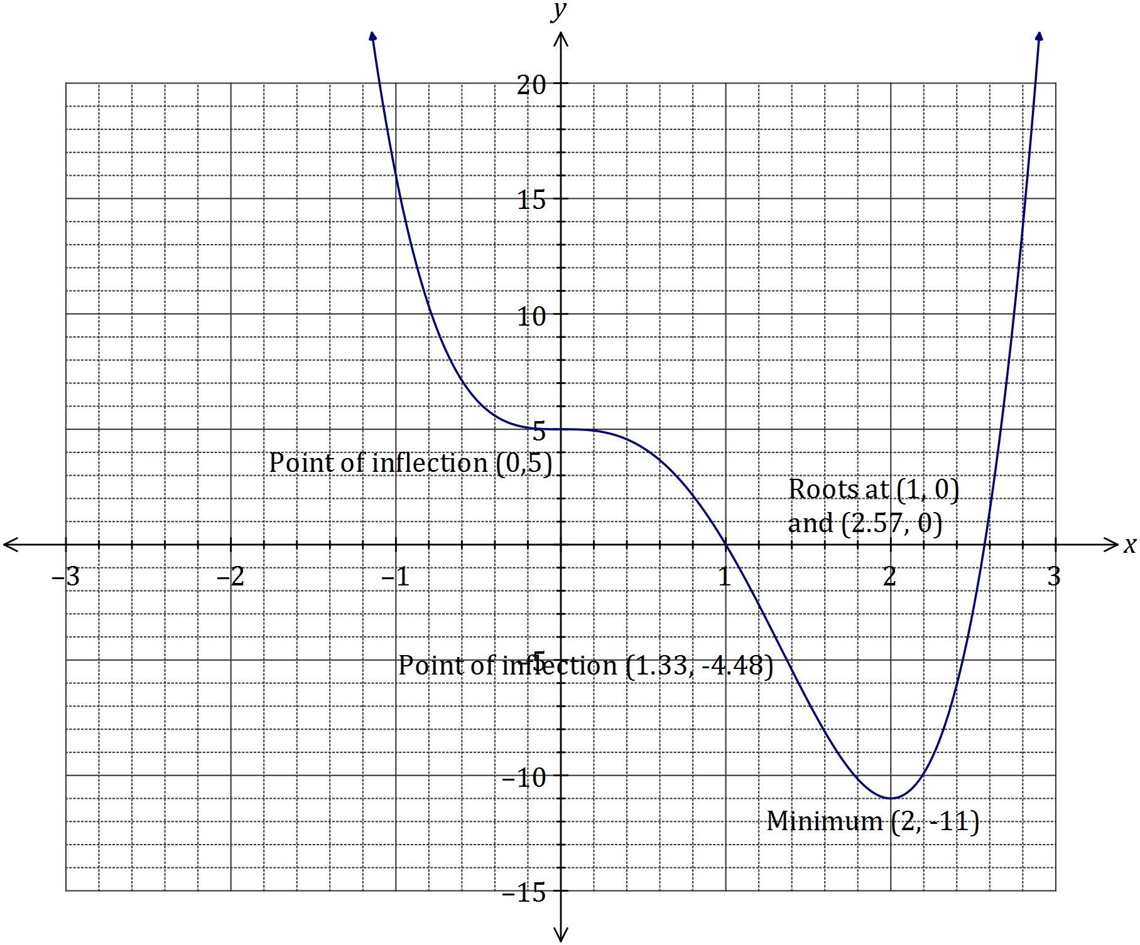

Solution
See graph
Specific behaviours
minimum
roots
points of inflection
smooth curve

Question 11 (7 marks)
(a) Four random variables $W$, $X$, $Y$ and $Z$ are defined below. State, with reasons, whether the distribution of the random variable is Bernoulli, binomial, uniform or none of these.
(4 marks)
The dice referred to is a cube with faces numbered with the integers 1, 2, 3, 4, 5 and 6.

(i) $W$ is the number of throws of a dice until a six is scored.
Solution
Neither - distribution is geometric

Specific behaviours
answer with reason

(ii) $X$ is the score when a dice is thrown.
Solution
Uniform - all outcomes are equally likely

Specific behaviours
answer with reason

(iii) $Y$ is the number of odd numbers showing when a dice is thrown.
Solution
Bernoulli - two complementary outcomes

Specific behaviours
answer with reason

(iv) $Z$ is the total of the scores when two dice are thrown.
Solution
Neither - distribution is triangular
Specific behaviours
answer with reason

(b) Pegs produced by a manufacturer are known to be defective with probability $p$, independently of each other. The pegs are sold in bags of $n$ for $4.95. The random variable $X$ is the number of faulty pegs in a bag.

If $E\left(X\right)=1.8$ and $Var\left(X\right)=1.728$, determine $n$ and $p$. (3 marks)
Solution
$$np=1.8, np\left(1-p\right)=1.728$$
$$∴1-p=\frac{1.728}{1.8}=0.96$$
$$p=0.04$$
$$n=\frac{1.8}{0.04}=45$$

Specific behaviours
writes equations for mean and variance
solves for $p$
solves for $n$

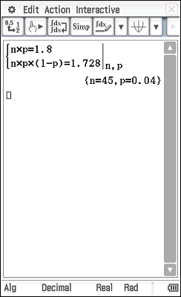

Question 12 (7 marks)
The graphs of the functions $f$ and $g$ are shown below, intersecting at the points $(b, c)$ and $(d, 0)$.

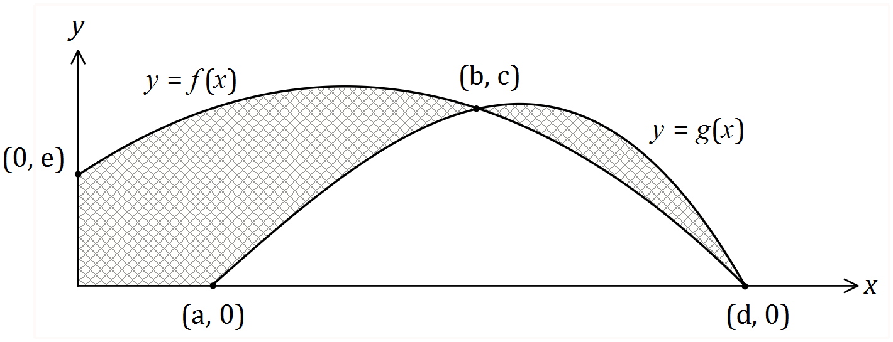

(a) Using definite integrals, write an expression for the area of the shaded region. (3 marks)
Solution
$$\text{Area}=\int_{0}^{b}{f(x)}dx-\int_{a}^{b}{g(x)}dx+\int_{b}^{d}{(g(x)-f(x))}dx$$

Specific behaviours
area from $x=0$ to $x=b$
area from $x=b$ to $x=d$
uses correct notation throughout

(b) Evaluate the area when $f\left(x\right)=15+12x-3x^{2}$ and $g\left(x\right)=-x^{3}+3x^{2}+13x-15$.
(4 marks)
Solution
$$a=1, b=3, d=5$$

$$\int_{0}^{3}{f\left(x\right)}dx-\int_{1}^{3}{g\left(x\right)}dx=72-28=44$$

$$\int_{3}^{5}{(g(x)-f(x))}dx=8$$

$$\text{Total area}=44+8=52 \text{sq units}$$

Specific behaviours
determines values of $a$, $b$ and $d$
area from $x=0$ to $x=b$
area from $x=b$ to $x=d$
correct area

Question 13 (9 marks)
75% of the avocados produced by a farm are known to be first grade, the rest being second grade. Trays of 24 avocados are filled at random in a packing shed and sent to market.

Let the random variable $X$ be the number of first grade avocados in a single tray.

(a) Explain why $X$ is a discrete random variable, and identify its probability distribution.
(2 marks)
Solution
$X$ is a DRV as it can only take integer values from 0 to 24.
$X$ follows a binomial distribution: $X\sim B(24, 0.75)$

Specific behaviours
explanation using discrete values
identifies binomial, with parameters

(b) Calculate the mean and standard deviation of $X$. (2 marks)
Solution
$$\overline{X}=24×0.75=18$$
$$σ_{x}=\sqrt{18×0.25}=\frac{3\sqrt{2}}{2}≈2.12$$

Specific behaviours
mean, standard deviation

(c) Determine the probability that a randomly chosen tray contains

(i) 18 first grade avocados. (1 mark)
Solution
$$P\left(X=18\right)=0.1853$$

Specific behaviours
probability

(ii) more than 15 but less than 20 first grade avocados. (2 marks)
Solution
$$P\left(16≤X≤19\right)=0.6320$$

Specific behaviours
uses correct bounds
probability

(d) In a random sample of 1000 trays, how many trays are likely to have fewer first grade than second grade avocados. (2 marks)
Solution
$$P\left(X≤11\right)=0.0021$$
$$0.0021×1000≈2 \text{trays}$$

Specific behaviours
identifies upper bound and calculates probability
calculates whole number of trays

Question 14 (8 marks)
The speed, in metres per second, of a car approaching a stop sign is shown in the graph below and can be modelled by the equation $v\left(t\right)=6\left(1+\cos\left(0.25t\right)+\sin^{2}\left(0.25t\right)\right)$, where $t$ represents the time in seconds.

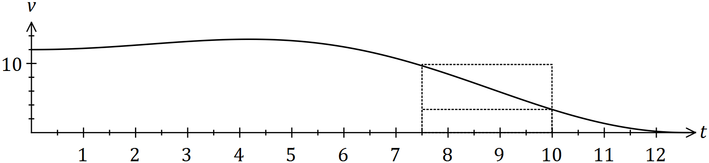

The area under the curve for any time interval represents the distance travelled by the car.

(a) Complete the table below, rounding to two decimal places. (2 marks)

$$t$$ | $$0$$ | $$2.5$$ | $$5$$ | $$7.5$$ | $$10$$
$$v(t)$$ | 12.00 | 12.92 | 13.30 | 9.66 | $$3.34$$
Solution
See table
Specific behaviours
values, rounding

(b) Complete the following table and hence estimate the distance travelled by the car during the first ten seconds by calculating the mean of the sums of the inscribed areas and the circumscribed areas, using four rectangles of width 2.5 seconds.
(The rectangles for the 7.5 to 10 second interval are shown on the graph.) (5 marks)

Interval | $$0-2.5$$ | $$2.5-5$$ | $$5-7.5$$ | $$7.5-10$$
Inscribed area | 30.0 | 32.3 | 24.15 | $$8.35$$
Circumscribed area | 32.3 | 33.25 | 33.25 | $$24.15$$
Solution
See table (may have slightly different values if using exact values of $v(t)$ rather than those from (a))
$$\sum{\text{Inscribed}}=94.8, \sum{\text{Circumscribed}}=122.95$$
$$\text{Estimate}=\frac{94.8+122.95}{2}≈108.9 \text{m}$$

Specific behaviours
values 1st col, values 2nd col, values 3rd col
sums
estimate that rounds to 109

(c) Suggest one change to the above procedure to improve the accuracy of the estimate.
(1 mark)
Solution
Use a larger number of thinner rectangles.

Specific behaviours
valid suggestion

Question 15 (10 marks)
A slot machine is programmed to operate at random, making various payouts after patrons pay $2 and press a start button. The random variable $X$ is the amount of the payout, in dollars, in one play of the machine. Each payout can be assumed to be independent of other payouts.

The probability, $P$, that the machine makes a certain payout, $x$, is shown in the table below.

Payout ($) $x$ | 0 | 1 | 2 | 5 | 10 | 20 | 50 | 100
Probability $P(X=x)$ | 0.25 | 0.45 | 0.2125 | 0.0625 | 0.0125 | 0.005 | 0.005 | 0.0025

(a) Determine the probability that

(i) in one play of the machine, a payout of more than $1 is made. (1 mark)
Solution
$$P\left(X>1\right)=1-\left(0.25+0.45\right)=0.3$$

Specific behaviours
states probability

(ii) in ten plays of the machine, it makes a payout of $5 no more than once. (2 marks)
Solution
$$Y\sim B\left(10, 0.0625\right)$$
$$P\left(Y≤1\right)=0.8741$$

Specific behaviours
indicates binomial distribution
calculates probability

(iii) in five plays of the machine, the second payout of $1 occurs on the fifth play.
(3 marks)
Solution
First payout in one of four plays:
$$W\sim B\left(4, 0.45\right)$$
$$P\left(W=1\right)=0.2995$$
Second payout:
$$P=0.2995×0.45=0.1348$$

Specific behaviours
uses first and second event
calculates $P$ for first event
calculates $P$ for both events

(b) Calculate the mean and standard deviation of $X$. (2 marks)
Solution
$$\overline{X}=1.9125, σ_{X}=6.321$$

Specific behaviours
mean
sd

(c) In the long run, what percentage of the player's money is returned to them? (2 marks)
Solution
$$\frac{1.9125}{2}×100=95.625\%$$

Specific behaviours
uses mean and payment
calculates percentage

Question 16 (12 marks)
Particle $P$ leaves point $A$ at time $t=0$ seconds and moves in a straight line with acceleration given by
$$a=\frac{16}{{\left(2t+1\right)}^{3}} {\text{ms}}^{-2}.$$

Particle $P$ has an initial velocity of $-3 {\text{ms}}^{-1}$ and point $A$ has a displacement of $4$ metres from the origin.

(a) Calculate the initial acceleration of $P$. (1 mark)
Solution
$$a\left(0\right)=16 {\text{ms}}^{-2}$$

Specific behaviours
correct value

(b) Is $P$ ever stationary? If your answer is yes, determine the time(s) when this happens. If your answer is no, explain why. (3 marks)

Solution
$$v=\int{a}dt=\frac{-4}{{\left(2t+1\right)}^{2}}+c$$
$$t=0, v=-3⇒c=1$$
$$v=\frac{-4}{{\left(2t+1\right)}^{2}}+1$$
$$v=0⇒t=0.5 \text{s}$$
$$\text{YES. P is stationary when} t=0.5 \text{s}$$

Specific behaviours
integrates to find velocity
correct constant
solves for zero

(c) Calculate the displacement of $P$ when $t=12$ seconds. (2 marks)
Solution
$$∆x=\int_{0}^{12}{v}dt=10.08$$
$$x\left(12\right)=4+10.08=14.08 \text{m}$$

Specific behaviours
integrates to find change in displacement
calculates actual displacement

(d) Calculate the change of displacement of $P$ during the third second. (2 marks)

Solution
$$∆x=\int_{2}^{3}{v}dt=\frac{31}{35}≈0.886 \text{m}$$

Specific behaviours
uses correct bounds
integrates to find change in displacement

(e) Determine the maximum speed of $P$ during the first three seconds and the time when this occurs. (2 marks)

Solution
Observe $\left|v\right|$ decreases then increases: $\left|v\left(0\right)\right|=3, \left|v\left(3\right)\right|≈0.92$
Hence maximum speed is 3 ms⁻¹.

Specific behaviours
examines $v$ at endpoints
determines maximum speed

(f) Calculate the total distance travelled by $P$ during the first three seconds. (2 marks)

Solution
$$d=\int_{0}^{3}{\left|v\right|}dt \text{or} d=-\int_{0}^{0.5}{v}dt+\int_{0.5}^{3}{v}dt$$
$$d=\frac{16}{7}≈2.286 \text{m}$$

Specific behaviours
uses integral(s) to determine distance
evaluates distance

Question 17 (10 marks)
Let the random variable $X$ be the number of vowels in a random selection of four letters from those in the word LOGARITHM, with no letter to be chosen more than once.

(a) Complete the probability distribution of $X$ below. (1 mark)

$$x$$ | $$0$$ | $$1$$ | $$2$$ | $$3$$
$$P(X=x)$$ | $$\frac{5}{42}$$ | $$\frac{10}{21}$$ | $$\frac{5}{14}$$ | $$\frac{1}{21}$$
Solution
$$1-\left(\frac{5}{42}+\frac{10}{21}+\frac{1}{21}\right)=\frac{5}{14}$$

Specific behaviours
uses sum of probabilities

(b) Show how the probability for $P(X=1)$ was calculated. (2 marks)
Solution
$$P\left(X=1\right)=\frac{\left(\begin{matrix}3 \\ 1\end{matrix}\right)×\left(\begin{matrix}6 \\ 3\end{matrix}\right)}{\left(\begin{matrix}9 \\ 4\end{matrix}\right)}=\frac{3×20}{126}=\frac{10}{21}$$

Specific behaviours
uses combinations for numerator
uses combinations for denominator and simplifies

(c) Determine $P(X≥1|X≤2)$. (2 marks)
Solution
$$P=\frac{\frac{10}{21}+\frac{5}{14}}{\frac{20}{21}}=\frac{5/6}{20/21}=\frac{7}{8}$$

Specific behaviours
obtains numerator
obtains denominator and simplifies

Let event $A$ occur when no vowels are chosen in random selection of four letters from those in the word LOGARITHM.

(d) State $P(\overline{A})$. (1 mark)
Solution
$$P\left(\overline{A}\right)=1-\frac{5}{42}=\frac{37}{42}$$

Specific behaviours
calculates probability

(e) Let $Y$ be a Bernoulli random variable with parameter $p=P(A)$. Determine the mean and standard deviation of $Y$. (2 marks)
Solution
$Y$ is a Bernoulli rv, so $\overline{Y}=p=\frac{5}{42}≈0.119$

$$σ_{Y}=\sqrt{(p\left(1-p\right)}=\sqrt{\frac{5}{42}×\frac{37}{42}}=\frac{\sqrt{185}}{42}≈0.324$$

Specific behaviours
indicates Bernoulli rv and states mean
states sd

(f) Determine the probability that $A$ occurs no more than twice in ten random selections of four letters from those in the word LOGARITHM. (2 marks)

Solution
$$W\sim B\left(10,\frac{5}{42}\right)$$

$$P\left(W≤2\right)=0.8933$$

Specific behaviours
indicates binomial distribution with parameters
calculates probability

Question 18 (8 marks)
A storage container of volume $36π$ cm³ is to be made in the form of a right circular cylinder with one end open. The material for the circular end costs 12c per square centimetre and for the curved side costs 9c per square centimetre.
(a) Show that the cost of materials for the container is $12πr^{2}+$ $\frac{648π}{r}$ cents, where $r$ is the radius of the cylinder. (4 marks)
Solution
$$V=πr^{2}h⇒h=\frac{V}{πr^{2}}$$
$$h=\frac{36π}{πr^{2}}=\frac{36}{r^{2}}$$

$$A_{CYL}=2πr^{2}+2πrh$$

$$C=\left(12\right)\left(πr^{2}\right)+\left(9\right)\left(2πrh\right)$$
$$=12πr^{2}+18πr×\frac{36}{r^{2}}$$
$$\left(=12πr^{2}+\frac{648π}{r}\right)$$

Specific behaviours
uses volume formula
expression for $h$ in terms of $r$
uses area formula adjusted for one end and cost
substitutes for $h$ in cost formula

(b) Use calculus techniques to determine the dimensions of the container that minimise its material costs and state this minimum cost. (4 marks)

Solution
$$C^{'}\left(r\right)=\frac{24{πr}^{3}-648π}{r^{2}}$$
$$C^{'}\left(r\right)=0⇒r=3 \text{cm}$$
$$C\left(3\right)=324π \text{cents} (\$10.18)$$
$$h=\frac{36}{3^{2}}=4 \text{cm}$$
$$\text{Min cost of} 324π \text{cents when} r=3 \text{cm} \text{and} h=4 \text{cm}$$

Specific behaviours
differentiates
equates $C^{'}\left(r\right)=0$ and solves for $r$
determines min cost
states dimensions

Question 19 (9 marks)
The graph of $y=f(x)$ is shown below. The areas between the curve and the $x-$ axis for regions $A$, $B$ and $C$ are $3$, $20$ and $12$ square units respectively.

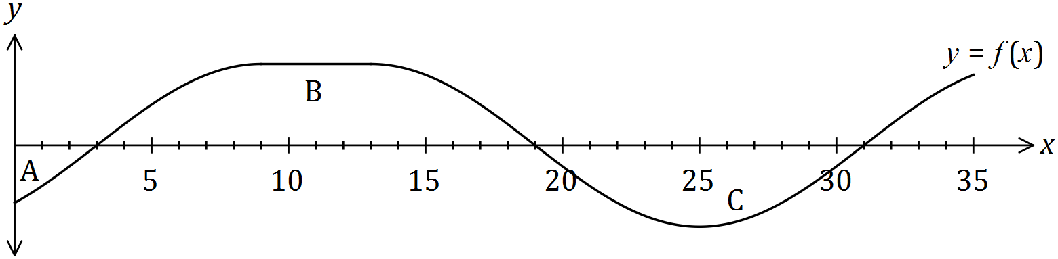

(a) Evaluate
Solution
$$\int_{0}^{31}{f\left(x\right)}dx=\left(-3\right)+20+\left(-12\right)=5$$

Specific behaviours
sums signed areas

(i) $\int_{0}^{31}{f(x)}dx$. (1 mark)

(ii) $\int_{19}^{0}{f(x)}dx$. (2 marks)
Solution
$$\int_{19}^{0}{f(x)}dx=-\int_{0}^{19}{f\left(x\right)}dx=-\left(\left(-3\right)+20\right)=-17$$
Specific behaviours
reverses limits and negates
sums signed areas

(iii) $\int_{3}^{31}{2-3f(x)}dx$. (3 marks)
Solution
$$\int_{3}^{31}{2-3f(x)}dx=\int_{3}^{31}{2}dx-3\int_{3}^{31}{f\left(x\right)}dx=56-3(8)=32$$
Specific behaviours
splits integral and takes difference
rectangle
function

It is also known that $A\left(31\right)=0$, where $A\left(x\right)=\int_{10}^{x}{f(t)}dt$.

(b) Evaluate
Solution
$$A\left(19\right)+\int_{19}^{31}{f\left(t\right)}dt=0⇒A\left(19\right)=12$$

Specific behaviours
states area of region $C$

(i) $A(19)$. (1 mark)

Solution
$$A\left(3\right)=-(20-12)=-8$$
$$A\left(0\right)=-8-(-3)=-5$$

Specific behaviours
deduces $A\left(3\right)$
deduces $A(0)$

(ii) $A(0)$. (2 marks)

Additional working space

Question number: _________

Additional working space

Question number: _________

© 2016 WA Exam Papers. Mercedes College has a non-exclusive licence to copy and communicate this paper for non-commercial, educational use within the school. No other copying, communication or use is permitted without the express written permission of WA Exam Papers. SN064-095-4.

